**EMPLOYEE MANAGEMENT**

Fig 1. describes the Employee Registration form as it appears on the screen. The form indicates the various buttons namely: (1) Search (2) Insert (3) Update (4) Delete (5) Exit. Along with the various buttons the form also includes a box where all the provided details of the Employees will be displayed. This Employee Management project will help in the successful registration of the Employee and will be capable of doing the changes and deleting the records.

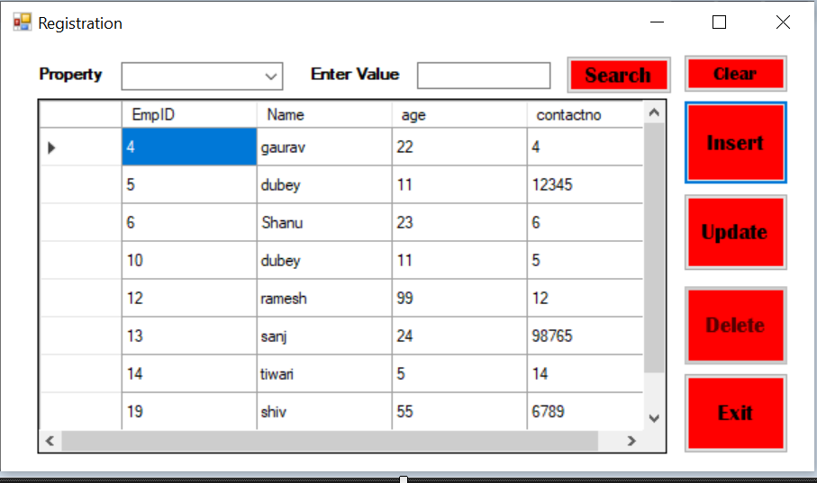

Fig. 1

**1- To Search a record:**

* On clicking the Property select any field, a list of all the fields will be dropped down.(Fig.2)

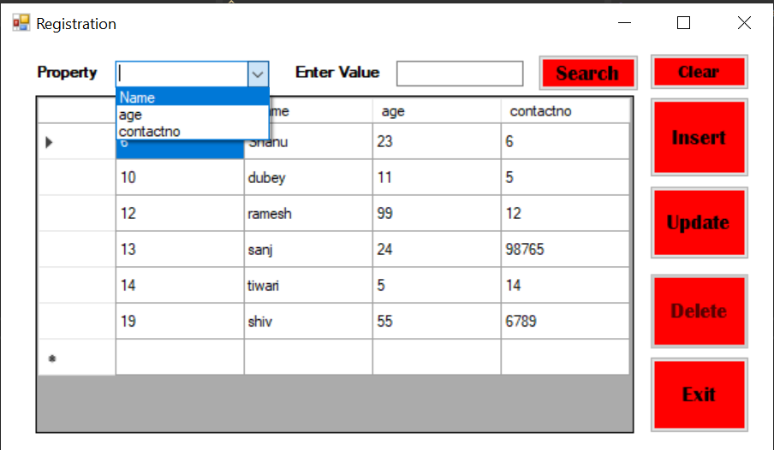

Fig. 2

* Choose any one of the given property.
* After choosing, enter any character associated to that property.
* Click Search button.(Fig 3)
* It will provide the existing records with the entered character.
* The Clear button will clear all the values, so we can search again.

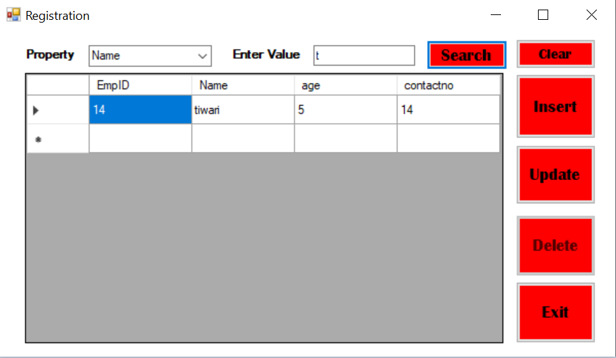

Fig. 3

**2- To Insert a record**:

* To Insert any record in the registration form, click the Insert button.(Fig. 4)



Fig. 4

NOTE: Provide Name, Age and Contact no. in the textboxes respectively.

All the fields are required to be filled and nothing should be left blank.

* Click Add.(Fig. 5)

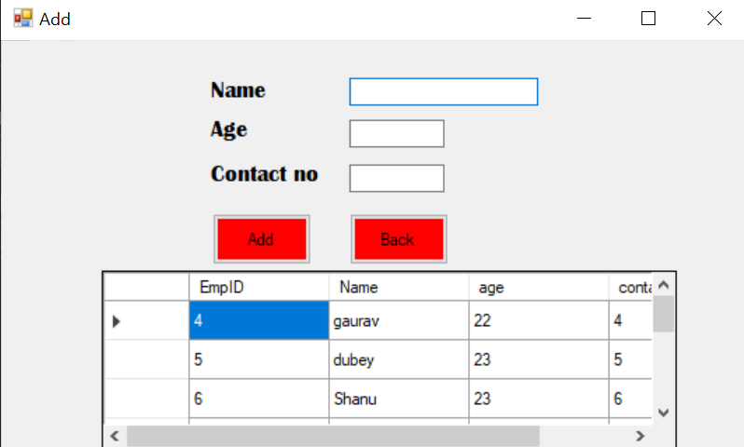

Fig. 5

* The popup box will indicate the message ‘Record Inserted’.(Fig. 6)

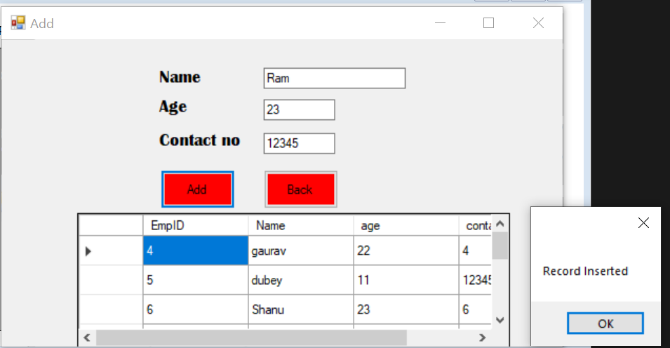

Fig. 6

* To go back to the registration form, click on the Back button.

**3- To Update a record:**

* To update any existing record in the form, click on the Update button.(Fig. 7)



Fig. 7

NOTE : For the Update button to become functional, double click on the record you want to update.

Make sure all the fields are filled and none of them is left blank.

* Update the Properties as per the requirement.
* Click on the Update button.(Fig. 8)

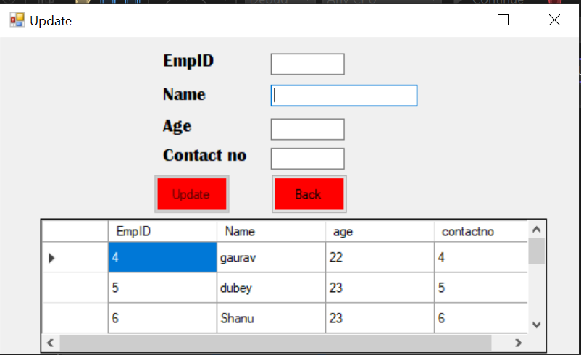

Fig. 8

* The popup box will be indicate the message ‘Record Updated’.(Fig. 9)

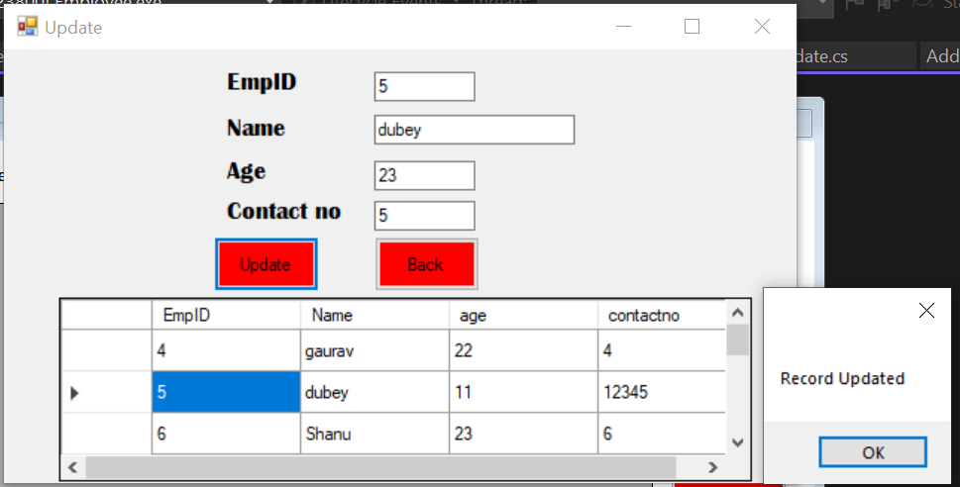

Fig. 9

* To go back to the registration form, click on the Back button.

**4- To Delete a record:**

* To delete a record from the form, click on the record you want to delete.(Fig. 10)

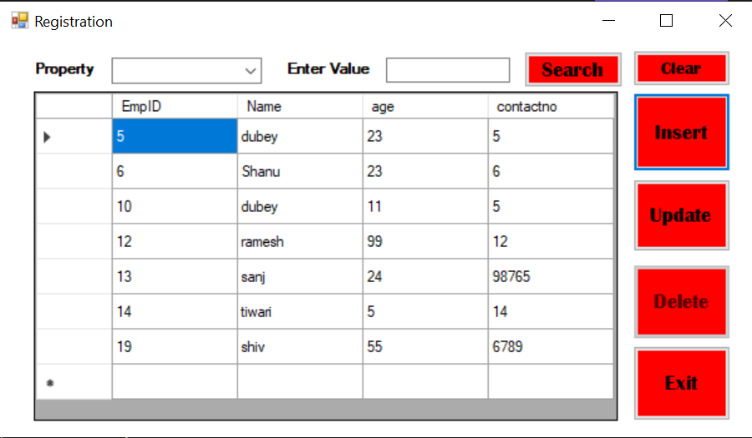

Fig. 10

* The record will be selected.
* Click on the delete button.
* The popup box will be indicating the message ‘Record Deleted’.(Fig. 11)

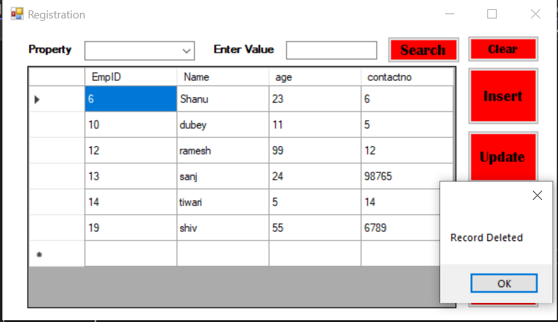

Fig. 11

**5- The Exit Button:**

To exit the form after doing the required changes, click on the Exit button. The application will close.